12/10/2019

Ivan McGann

Mobile Applications Development 3

Game Project

Design Document

Contents

Introduction 1

Overview 2

Aims and Objectives 3

Genres 3

Shooters – Classic, horizontal or vertical scrolling 3

Platformers – Classic or 2D 5

Puzzle – Action Puzzle or Desktop Puzzle 6

Traditional Game – Board Games 7

Project Design: 8

Appendix 9

Articles for research: 9

Screenshots 9

## 

## Introduction

My name is Ivan McGann. I am a 4th year student in GMIT studying computing and software development. This is a design document to be used as an aid and an introduction to my project in the subject of Mobile Application Development. The aim of this project is to design and then make a 2D game of a specified genre in Unity. The created game needs to feature a balanced learning curve while also being simplistic enough to allow the player to be able to pick up and play. Before I describe and display the chosen design of the project, I will take a brief look at the genres of games for discussion followed then by taking a closer look at the game I intend to create and the inspirations or traits of the category. As always with a design document the initial design may not match the final design of the product due to unforeseen circumstances. I have little experience working within the development environment of Unity so the quality of the final project based on its design may not match the initial vision I had for the project.

## Overview

I plan on following the guideline principles of making the gameplay and overall design of the game as simplistic as possible and valuing them ahead of the aesthetic design of the game. This is a philosophy that some companies work diligently towards and try to master. Nintendo for example have used a design philosophy of creating and mastering the feel of a gameplay mechanic first then creating a game around that balanced mechanic. [[1]](https://www.youtube.com/watch?v=2u6HTG8LuXQ)

A more classical take on game design was the subtle AI implemented on enemy ghosts in the arcade classic Pacman. Each ghost has different characteristics to differentiate it from other the ghosts when chasing the player. The red ghost will aggressively pursue the player, while the pink ghost will attempt to ambush the player by trying to predict the players path. The orange ghost will move around the map in a random unpredictable behaviour and finally the cyan ghost will patrol the area of the map he is in. [[2]](https://dev.to/code2bits/pac-man-patterns--ghost-movement-strategy-pattern-1k1a)

Meanwhile Bungie upon designing the gameplay of Halo looked at a 30 second loop of often repetitive actions that can be stretched out over a multiple hour game and even competitive multiplayer if that first 30 seconds of combat satisfies the user. [[3]](https://www.engadget.com/2011/07/14/half-minute-halo-an-interview-with-jaime-griesemer/?guccounter=1) This can be done by tweaking Artificial Intelligence (AI) and the feeling of offering the player more of a choice on how to deal with developing situations in the game. This demonstrates how important a good control scheme can be to the overall enjoyment of the game and how it can be used as a gauge to set a good game apart from the rest of the titles in its genre, a well-designed control scheme can become the standard for the genre even if at first it can seem unusual to the player. [[5]](https://www.neogaf.com/threads/first-fps-console-game-to-use-twin-stick-layout-for-moving-and-aiming.1206250/)

With this project we are also allowed to tweak the formula of an existing game to expand upon the genre or take it in a different direction from the original vision. There could be many ways to expand on a genre from turning a game about completing levels to be a time-based mode or score attack focused games based more on leaderboards. Even something as simple as the design of giving the player the ability of restarting a game fast can itself become a key game mechanic. The Trials videogame series developed by RedLynx uses this mechanic to the best of its ability. The game itself is based on completing obstacle courses in the fastest possible time on a motorcycle, these courses feature obstacles to challenges to the player whether it’s a ramp or a drop. It also incentivises the player to replay the game and beat their previous times, this means the player will pursue a faster time and perfect runs. The key is to limit the level of frustration in the game, this is achieved with the use of a single button to immediately restart the course or send you back to the nearest checkpoint. This simple solution eliminates much of the frustration for the player and allows more of a focus on the end. As well as limiting frustration it also makes the overall user experience smoother for the player which benefits the enjoyment of the game. [[4]](https://kotaku.com/trials-rising-the-kotaku-review-1832870608)

## Aims and Objectives

I am choosing not to use the clone and tweak approach of a given game as I often feel with this method it can lead to mixed results. I’m basing this approach on several summations; often a developer can attempt to do this with a game and lead to unflattering comparisons of the game they try to imitate. Whether it’s not having the same level of feel with the gameplay or a level design that compliments the gameplay in a way to accentuate the platforming or shooting for example. There are modifications to some games that have proven to be useful like Nintendo reskinning the internally developed game for the Western release of Super Mario Bros 2 due to the perceived difficulty of the Japanese release of the NES game. [[6]](https://en.wikipedia.org/wiki/Super_Mario_Bros._2) There are some uses to modifying games with language translations of Japanese only releases of older Nintendo games to English which were never given a Western release. There are also interesting changes that can be made to finished games such as layout randomizer for A link to the Past which changes locations of weapons and Dungeons layouts, adding replayability. [[7]](https://alttpr.com/en) But often these can also result in the game having bugs or the introduction of unforeseen errors like the game freezing, save file issues and game crashes.

Looking at the choices of genres I am going to do a shooter, I have ideas for most of the genres I described, but I am tentatively choosing this as it’s a genre I have some experience in playing. While I do have experience playing shooters, I am a novice when it comes to Unity game development. I find developing a game that is entertaining and of a high quality is unlikely given the time restraints. Instead I will look at doing a top down 2D shooter. [[20]](http://www.racketboy.com/retro/shmups-101-a-beginners-guide-to-2d-shooters) The reason I’d like to make a game in this genre is because of the difficulty that the genre is known for beginners, I would take a more casual approach to the genre. Games like Ikaruga, Gunbird 2, R-Type II and Radiant Silvergun are known for their high level of difficulty (often referred to a Bullet-Hell shooters) but some are also considered the height of their genre when it comes to quality. I will look to create a game that is less punishing that others like these that maybe focuses more of a score chasing than stage-based game design. I will go into more detail on the design below.

My ideas for other genres would be a 2D platformer where you need to avoid enemies and use the environment to get past them such as pushing objects from a height to block enemy paths and create ones for the player. For a puzzle game I was thinking about a game like Marble Madness where you would guide a ball through obstacle courses and use physics (maybe using a gyroscope in handheld mode) that would allow the ball to drop down to a lower area of ever increasing in difficulty levels. I always liked the idea of making a card based traditional game with a rock, paper, scissors approach where one type of card would beat another but always have its own weakness. It would be hard for me to create this type of game as it requires a balanced AI that would challenge the player but also would not be overly punishing to the player.

## 

## Genres

### Shooters – Classic, horizontal or vertical scrolling

Shooters come in many variations of the genre and like many genres they often change and adapt to type as the technology they are created in becomes more powerful. I will look at shooters in each genre and talk about how they differ from each other and the

2D shooters are games where the camera perspective displays a two-dimensional surface where the player, the level layout and enemies are all on the same *flat* level. These can be side scrollers or even feature a mild use of platforming to offer variety and expanded level layouts. An example of these type of games would be Contra, Megaman or Gradius. Gradius is a classic space shooter where the player moves from left to right as oncoming enemies come from the right-hand side of the screen. The gameplay variety is in enemy patterns and weapon pickups where the player’s ship temporarily gains different bullet types to attack the enemy. Megaman, Contra and Shadow Complex are examples of 2D shooters that feature more of a use of platforming. This can offer more variety than the classic games do where most of the time you are only moving to dodge and shoot. These games still offer weapon/gun upgrades but find it easier to offer secrets and different ways to defeat a boss or finish a level. 2D shooters in general often feature less of an emphasis on ammunition preservation or objectives and more emphasises a use of different ammunition types, gaining scores and boss fights at the end of a level to add variety or challenge to the game.

Third person shooters feature the camera being behind the perspective of the player. There is a larger use of environment and level design. Many third person shooters feature more of a use of cover than 2D shooters do. [[8]](https://www.polygon.com/2017/8/18/16169218/cover-systems-shooters-gears-of-war-uncharted) Popularised by Gears of War which was partially influenced by the mainly unknown shooter Kill Switch the use of cover in third person games has unintentionally stunted the growth of the genre according to some. Examples of the genre are Gears of War, Uncharted and Dead Space.

First person features the camera predominantly in front of the player in a first-person perspective. This perspective requires a more limited use of some features such as platforming and more of an emphasis on environmental detail and design. It is a genre that has always been widely popular and is now a large part of the popularity in online multiplayer gaming. Examples of the genre include games such as Call of Duty, Doom and Half Life.

These genre’s themselves can be separated into genres within themselves such as survival horror, military based, *shmups*(an abbreviation of the term shoot-em-up, often used to describe old school shooters) or Battle Royale games which are seen as the new market leader in the genre from their popularity from titles such as PlayerUnknown’s BattleGround(PUBG), Fortnite and is featured in games such as Battlefield and Call of Duty. There is still a market however for more classical shooters like DOOM, Wolfenstein and Prey but many view single player shooters with no multiplayer features a risk; such is the evolution of the genre. Many shooters have also experimented with physics and mechanics to expand on the genre. Max Payne for instance used a slowdown of time mechanic popularised in mainstream media at the time in movies like The Matrix. Half-life 1 and 2 were also seen as milestones in the genre from a narrative sense to the player with environmental storytelling and for the sequel’s use of physics to solve puzzles and battle enemies using the gravity gun. [[9]](https://slashdot.org/story/06/03/24/1926234/gdc---physics-in-half-life-2)

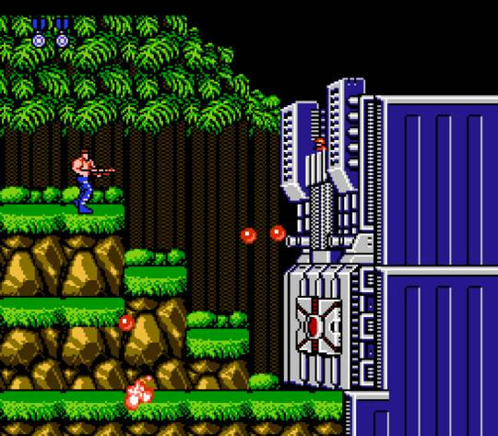

### Platformers – Classic or 2D

Platformers involve the protagonist traversing a level or environment to get to an end goal or point of the level. The player can have weapons but also be the weapon themselves. Many platformers feature a variety of levels and boss fights. Some platformers such as Sonic feature level design with enough complexity to have multiple routes throughout the level. [[10]](https://www.gamasutra.com/view/news/117691/Analysis_Sonics_Game_Design_Influence.php) Platformers can be complex to create and the genre in general has fluctuated in popularity at times over the past few decades. Once the gaming industry moved from making mainly 2D dimensional platformers many companies struggled with the move to 3D game development from 2D, much of the issues of 3D platformers was developers lack of experience developing games and environments in 3D. This became more apparent with the abundance of mascot platformers that were released at the time and received a lukewarm reception from critics. Often cited as being one of the best games of all time Super Mario 64 is still widely believed to be the best 3D platformer ever made despite being one of the first to be released, Mario seems to be one of the few 2D videogame series that have flourished in a 3D environment.

In recent years there has been an increase of games created in 2D through digital stores with indie games featuring art and mechanics not capable in the games that inspired them. For instance, Shovel Knight [[11]](https://www.youtube.com/watch?v=rHhX5GtWNr8) is a game inspired by Nintendo Entertainment Era (NES) games and the art style shows that era of games is a clear inspiration but at times they go beyond the power that was available in the late 1980’s or early 1990’s when the NES was prominent. Another interesting game is Braid, developed by Jonathan Blow and featured in ‘Indie Game the Movie’ Braid [[12]](https://www.youtube.com/watch?v=8dinUbg2h70) is a platformer which features time-based mechanics. Braid allows the player to rewind time as a primary mechanic, but this is changed up in every world there are new mechanics in the levels; like time being controlled by the players horizontal axis or time running backwards by default. Other modern 2D platformers include Celeste and Super Meat Boy. These games rely more on the perfection of tight controls and quick reactions. Celeste allows the player to tweak some settings to allow for slower mechanics but also features specifically designed levels called the B & C sides to offer the player more of a challenge to those who mastered the game’s controls.

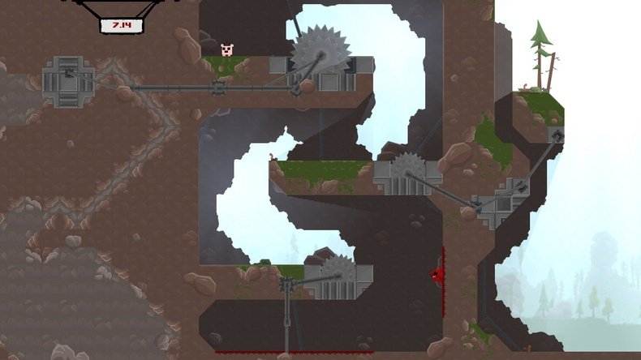

### Puzzle – Action Puzzle or Desktop Puzzle

Puzzle video games involve the mechanic of solving problems as its key central gameplay mechanic. The types of puzzles and problems can vary in their variety. They can require the player to problem solve a situation to progress or combine items to create their solution. It’s also a gameplay mechanic that often appears in other games outside of the genre to offer some variety and a change of pace. Puzzle games often lean to the use of tries or attempts more than lives.

A more familiar puzzle game that people may not consider is Tetris. It features tile matching and a high level of problem solving as the game is constantly in progress The player must juggles with the static field at the bottom of the screen of fallen pieces to clear lines and also deal with the next piece that is going to scroll down the screen.

Lucasarts have created several puzzle games [[13]](https://www.newstatesman.com/culture/games/2019/01/rise-and-fall-point-and-click-adventure-game) in the 1990’s and early 2000’s before their closure when its parent company were sold to Disney. These include games such as Monkey Island, Sam and Max, and Day of the Tentacle. The games rely on the gameplay mechanic of point and click but task the player to solve problems or puzzles that often require lateral thinking. These style of games can lead to a lot of frustration at times for the player to deal with puzzles with often bizarre solutions and some cited this as the reason the point & click genre as a whole declined in popularity after the release of Grim Fandango. To provide some help to the player these games will often feature the use of a hint system to help the player with a puzzle they may be struggling with and reduce frustration.

In more recent years the puzzle genre has been expanded to be based around a narrative of a story as a reward for progression such as the Zero Escape series where the character is asked to solve puzzles as a way to escape a room to progress the story. Another example that became popular on the Nintendo DS was the Professor Layton series, these games offered over one hundred puzzles of a wide variety such as spotting the difference, riddles like the chicken crossing [[14]](https://www.mathsisfun.com/chicken_crossing_solution.html) and even chess-based puzzles.

Modern classic puzzle games include Portal and The Witness. Portal was developed as a spiritual successor to a student created game which lead to it drawing interest from Valve. It featured in the Orange Box as what many expected to be a bonus for a Half Life 2 collection but quickly drew the attention of the public for its clever use of a portal gun. [[15]](https://www.gamasutra.com/view/feature/132233/thinking_with_portals_creating_.php?print=1) The player can shoot two portals, one an entrance and the other an exit. The game uses physics like gravity and momentum to expand this gently as the game progresses and this led to an equally well received sequel being released over three years later. The Witness designed by Jonathan Blow features almost exclusive use of line puzzles through an interface on the screen of the player. The game contains over five hundred of these puzzles as the player progresses through a mysterious Island.

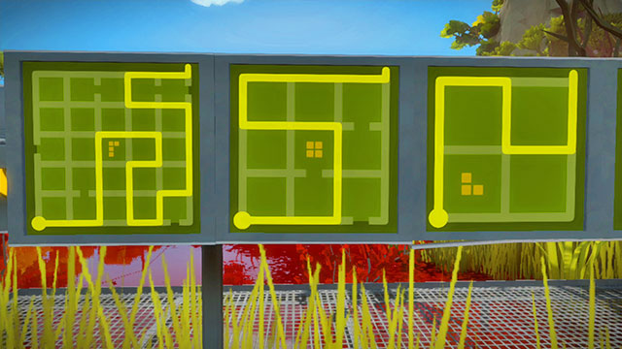

### Traditional Game – Board Games

Traditional games offer a more convenient way for some to play games that you would normally play on a tabletop such as card games or board games. [[16]](http://www.leagueofgamemakers.com/artificial-intelligence-in-board-games/) Most of these games are built with more of a casual approach to the design, made to be played more to pass time than be an overly challenging experience. These games require an artificial intelligence (AI) to be developed and balanced so that it tests the player but never to a degree to where the player could feel they are often in a position where they cannot win. The goal of the AI here is to mimic the feeling of playing another human player. The advantage of developing these games is that there is a written set of rules and corresponding responses for each game are generally known.

Examples of a traditional game would be something like chess or checkers. Checkers is obviously an easier game to balance the AI with as the pieces don’t have a myriad of rules, both players will continue until there are no pieces left. Whereas with chess [[17]](http://www.chesscoachonline.com/chess-articles/chess-rules) each piece must abide by its own set of rules e.g. Queen can move any number of vacant squares diagonally, horizontally, or vertically. There are also several winning conditions that can lead to a check mate and draws are entirely plausible albeit rare.

Card games are also very popular games. Solitaire, poker and cribbage are widely available to play either as freeware games or through online portals. [[18]](https://cardgames.io/) Solitaire is played mainly as a single player game but can be played by two players. The game requires the player to re-order a deck by means of shifting cards by suit and rank. It comes pre-installed on windows systems. There are over 150 varieties of solitaire such as Canfield and chain solitaire. There are other games such as Sudoku, often played on paper but can be played online. It’s a traditional puzzle game that is a number placement puzzle. The objective is to fill out a 9 × 9 grid with digits so that each column, each row, and each of the nine 3 × 3 sub-grids that compose the grid must contain all digits from 1 to 9.

There are other card games on the market that aren’t traditional card games but are more focused on being collectable card games, these feature their own unique set of rules and ways to play. Games such as Heartstone based off the World of Warcraft franchise, the game is a turn-based card game between two opponents, using constructed decks of 30 cards along with a selected hero with a unique power. The game features several modes of play, including casual and ranked matches and single player adventures. Gwent is part of The Witcher videogame series, first introduced in the Witcher 3 as a side activity. Gwent [[19]](https://www.playgwent.com/en) is a turn-based card game between two players (human or AI) and each game is the best of three rounds. Each player must play one card on each turn from a deck of at least twenty-five cards. Each deck belongs to a unique faction and each of these have different leaders each of which have individual abilities.

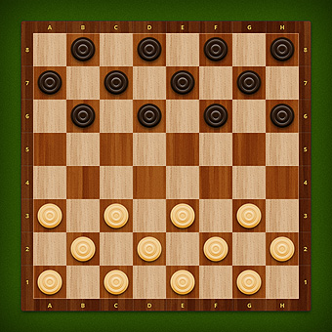

### Project Design:

For the design, you need to create the following components

1. **Front End**: A term applied to all menus and screens that occur outside of the gameplay. This takes the player from the title screen to the point that gameplay begins.

2. **In-Game Menus**: A set of menus and screens accessed in-game, often from a pause menu. These form part of the game mechanisms rather than being distinctly separate.

3. **Control Mechanisms**: The way in which the player controls the game entities. Many games have just one control mechanism.

4. **The Game**: The gameplay screens showing the initial setup, how the action starts, a midpoint in play and the winning/progression conditions depending on the game you are designing. If the game is episodic in nature, then explain how episodes are defined and how the player moves between them.

## Appendix

### Articles for research:

1. Mark Brown video on Nintendo game design:

<https://www.youtube.com/watch?v=2u6HTG8LuXQ>

1. Pacman Ghost Characteristics:

<https://www.webpacman.com/ghosts.html>

1. Halo half minute hero article:

<https://www.engadget.com/2011/07/14/half-minute-halo-an-interview-with-jaime-griesemer/?guccounter=1>

1. Trials review:

<https://kotaku.com/trials-rising-the-kotaku-review-1832870608>

1. Twin stick shooters design discussion:

<https://www.neogaf.com/threads/first-fps-console-game-to-use-twin-stick-layout-for-moving-and-aiming.1206250/>

1. Super Mario Bros 2 western release:

<https://en.wikipedia.org/wiki/Super_Mario_Bros._2>

1. Link to the Past randomiser:

<https://alttpr.com/en>

1. Cover in shooters:

<https://www.polygon.com/2017/8/18/16169218/cover-systems-shooters-gears-of-war-uncharted>

1. Half Life 2 physics:

<https://slashdot.org/story/06/03/24/1926234/gdc---physics-in-half-life-2>

1. Sonic Design’s influence:

<https://www.gamasutra.com/view/news/117691/Analysis_Sonics_Game_Design_Influence.php>

1. Shovel Knight’s nostalgic design:

<https://www.youtube.com/watch?v=rHhX5GtWNr8>

1. Braid GDC talk:

<https://www.youtube.com/watch?v=8dinUbg2h70>

1. Lucasarts games:

<https://www.newstatesman.com/culture/games/2019/01/rise-and-fall-point-and-click-adventure-game>

1. Puzzle explanation:

<https://www.mathsisfun.com/chicken_crossing_solution.html>

1. Portal game design:

<https://www.gamasutra.com/view/feature/132233/thinking_with_portals_creating_.php?print=1>

1. Board game AI:

<http://www.leagueofgamemakers.com/artificial-intelligence-in-board-games/>

1. The rules of Chess:

<http://www.chesscoachonline.com/chess-articles/chess-rules>

1. Card games online portal:

<https://cardgames.io/>

1. Gwent game link:

<https://www.playgwent.com/en>

1. 2D Shooters:

<http://www.racketboy.com/retro/shmups-101-a-beginners-guide-to-2d-shooters>

### Screenshots

Contra:

<https://gamefaqs.gamespot.com/nes/563399-contra/images/227>

Super Meat Boy:

<http://supermeatboy.wikia.com/wiki/File:Screenshot_1.jpg>

The Witness:

<https://guides.gamepressure.com/thewitness/guide.asp?ID=33914>

Online Checkers:

<https://skillgamesboard.com/play-checkers-online.aspx>